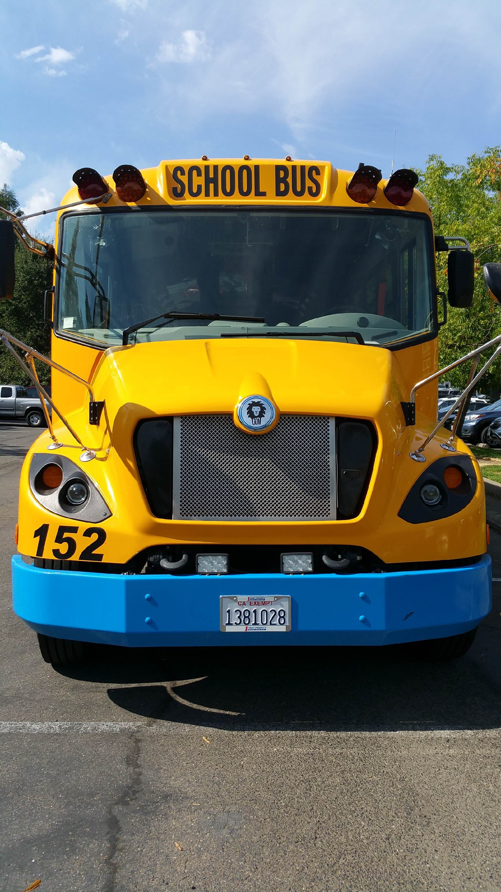
Monterey Bay Zero Emission School Bus Program

Application Form

Applicant Information:
School District:
Address:
Bus Storage Address:
City:
State, Zip:
School Bus Contact:
Primary Phone Number:
Cell Phone Number:
Email Address:
Bus Information:
Make:
Model:
Year:
Number of Passengers:
Bus Type: C, D, Special Ed.(SE) :
GVWR:
Battery Capacity:
Specified Driving Range @ Full Charge:
EV infrastructrure funding needed? (Y/N):
Total Number and Cost of Bus(es) including tax, delivery and charging infrastructure:

