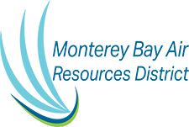
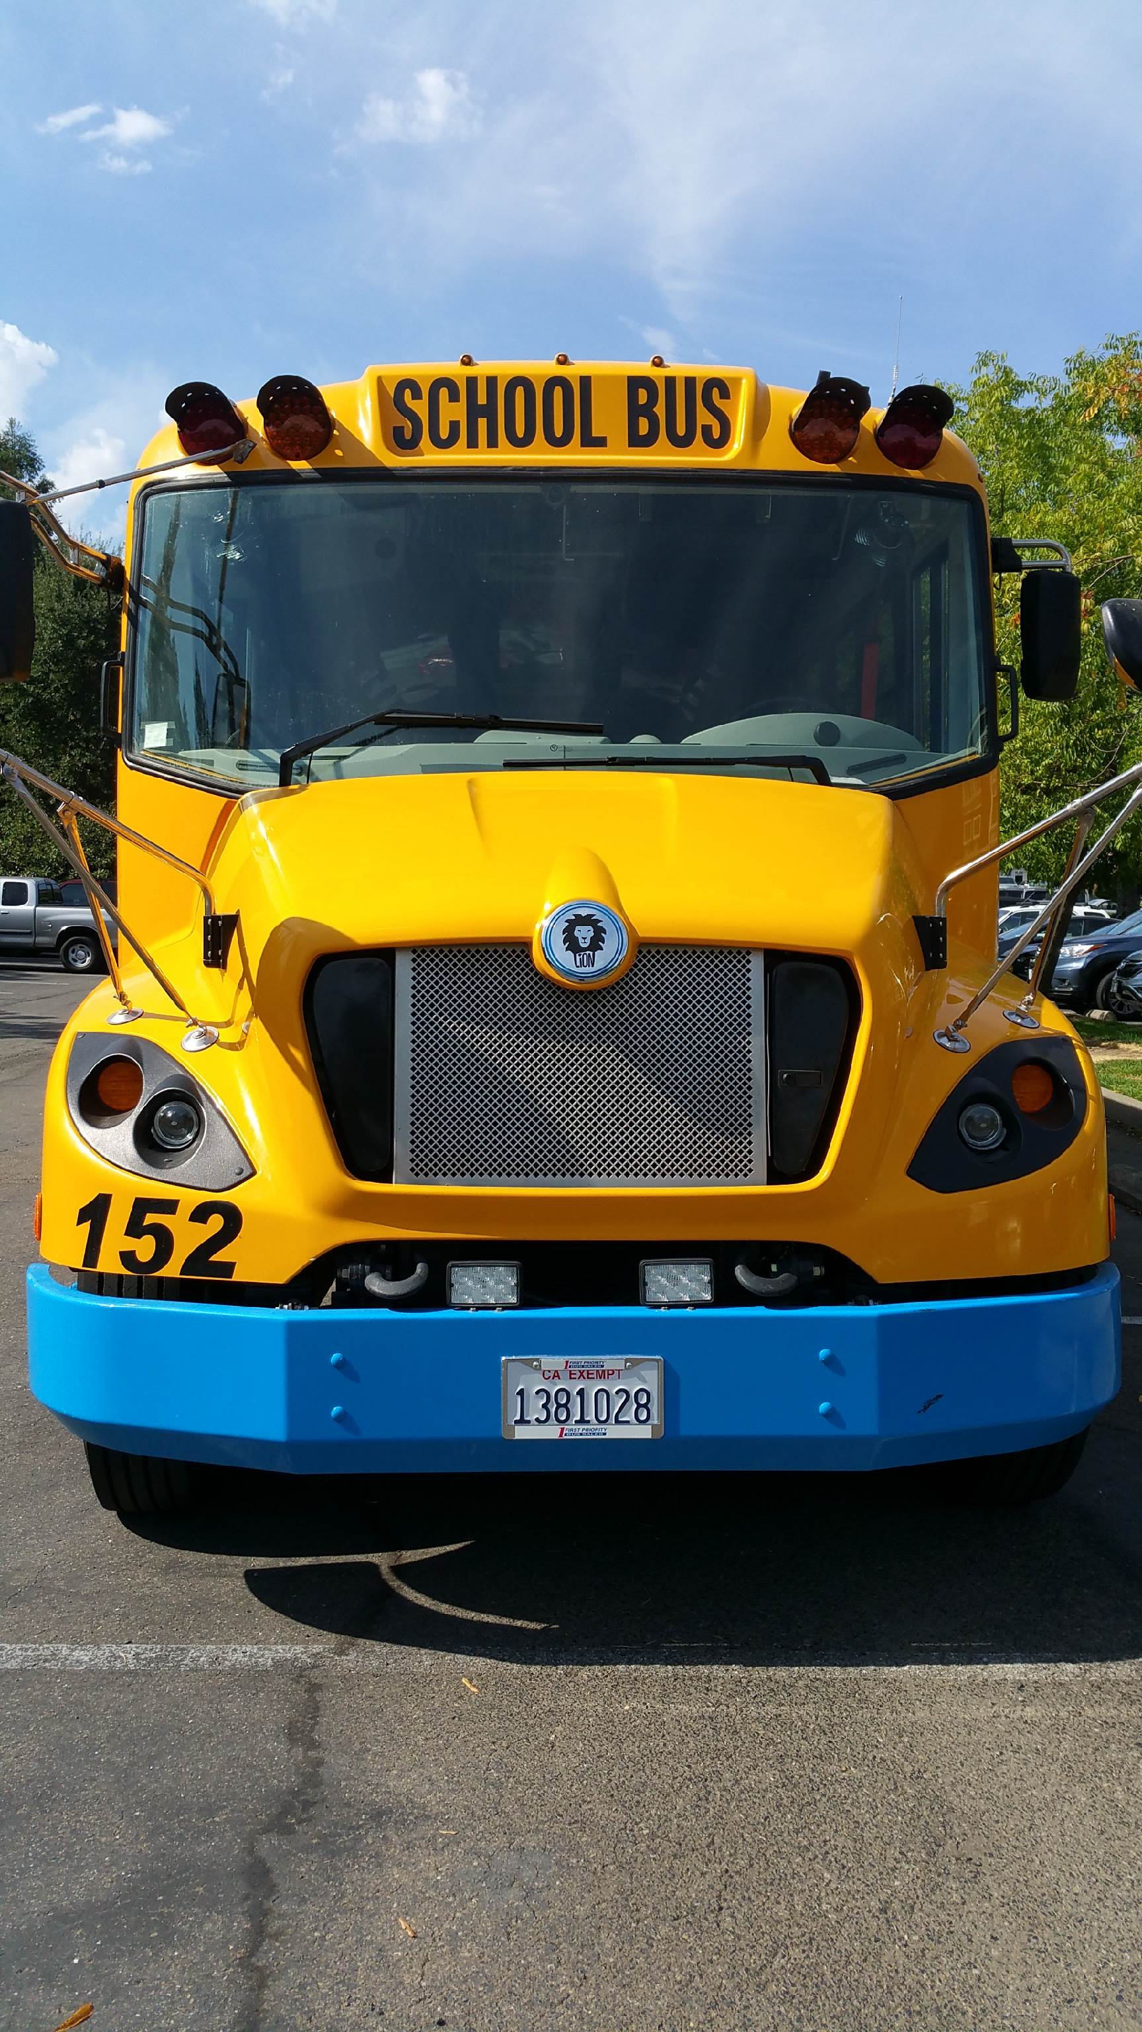
FY20/21 Program Requirements
Monterey Bay Zero Emission School Bus Program (ZESBP)
Serving Monterey, San Benito, and Santa Cruz Counties

Requirements:
- All eligible public School Districts must be located in either Monterey, San Benito or Santa Cruz county. Private or charter schools are not eligible to participate in the program.
- Applicant must perform a site assessment for the charging of the electric school bus and ensure that the charge station infrastructure installation has been completed and is fully operational prior to taking delivery of the bus.
- Applicants must purchase the electric school bus from the HVIP approved vendors and associated original equipment manufacturer (OEMs) list: https://www.californiahvip.org/eligible-technologies/#approved-vendor-list
- Applicant must submit a formal quotation from the school bus OEM along with the application.
- The new school bus must be registered with the DMV and certified by the CHP within Monterey, San Benito or Santa Cruz counties.
- Applicant must retain ownership and operate the electric school bus for a minimum of 60 consecutive months immediately after the purchase.
ZESBP Process:

- The ZESBP award will be in the form of an executed grant agreement between the school district and MBARD and will be funded in combination from various sources : AB617, AB923, Carl Moyer Program, Local Offsite Mitigation fees, the Hybrid and Zero-Emission Truck and Bus Voucher Incentive Project (HVIP), or Monterey Bay Community Power (MBCP) funds.
- The MBARD voucher award will cover the difference between the full cost of the electric bus and other leveraged voucher award amounts available referenced above.
- Funding for EV charging infrastructure up to $20,000 will be included in the voucher award.
- Reimbursement will be sent to the school district awardee upon receipt of the electric school bus and after submission of the required documentation to MBARD as stated in the grant agreement.

